Name : Ali Hassaan Mughal Reg No : 173627

Code:

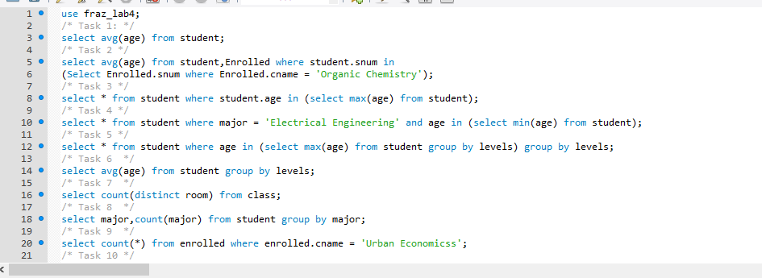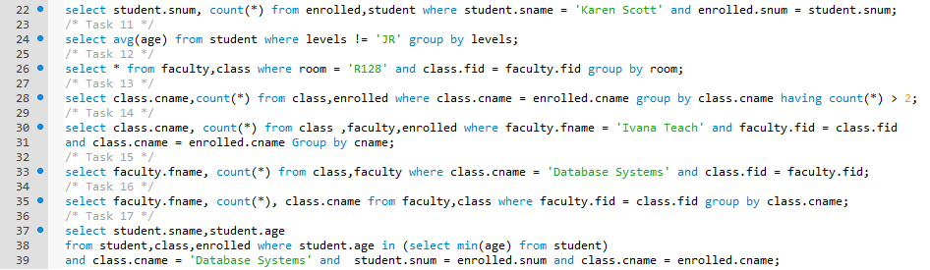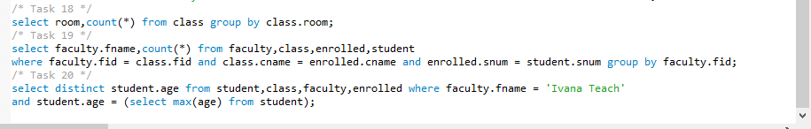

OUTPUT 1



OUTPUT 2



OUTPUT 3



OUTPUT 4

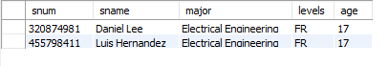

OUTPUT 5

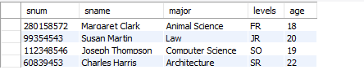

OUTPUT 6

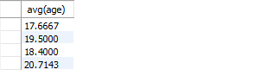

OUTPUT 7

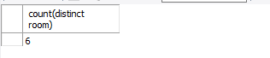

OUTPUT 8

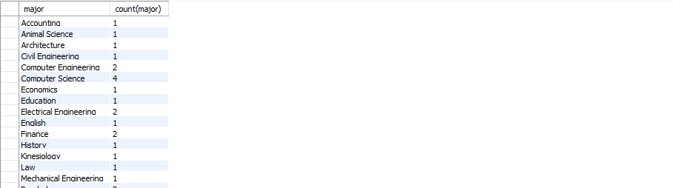OUTPUT 9



OUTPUT 10



OUTPUT 11

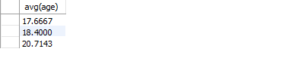

OUTPUT 12

OUTPUT 13

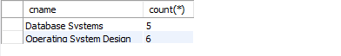

OUTPUT 14



OUTPUT 15



OUTPUT 16

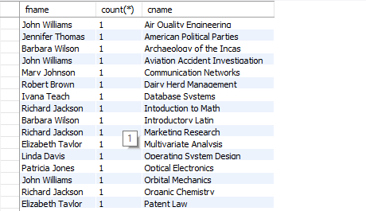

OUTPUT 17



OUTPUT 18

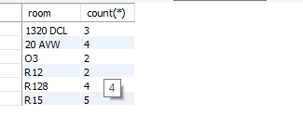

OUTPUT 19

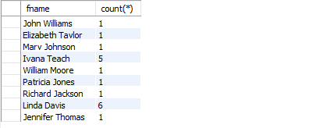

OUTPUT 20

